

**SIX WEEKS SUMMER TRAINING**

**REPORT**

on

***The Complete Web Development Course***

Submitted by

**Lella Chandu Sai**

**Registration No.:** *11404463*

**Program Name:** 1202:: *B. Tech –CSE*

Under the Guidance of

**Udemy.com**

**School of Computer Science & Engineering**

**Lovely Professional University**

(June-July,2017)

**DECLARATION**

I hereby declare that I have completed my six weeks summer training at www.udemy.com starting from 10-June-2017 to 25-July-2017. I declare that I have worked with full dedication during these six weeks of training and my learning outcomes fulfill the requirements of training for the award of degree of Bachelor of Technology in Computer Science and Engineering, Lovely Professional University, Phagwara.

(Signature of student)

Lella Chandusai

Reg No: 11404463

Date: July 31, 2017

**ACKNOWLEDGEMENT**

I Lella Chandu Sai, registration number 11404463, pursuing bachelor’s degree (4th year) in Computer Science and Engineering from Lovely Professional University, wish to express my sincere gratitude to The School of Complete Web Development for providing me an opportunity to do my summer Training Course in “www.udemy.com”.

I sincerely thank the website for their proper guidance and encouragement in carrying out this Summer Training Course. I also wish to express my gratitude to the Instructors and Mentors of The School of Complete Web Development of who rendered their help during the period of my Summer Training Course.

I also thank the website www.udemy.com for providing this kind of platform for the students who are aspiring to learn and master the new Skills and achieving their goals by learning from their extensive library. I would like to thank them for giving me this opportunity to embark on this Course to learn something new.

**Lella Chandusai**

**Training Certificate**

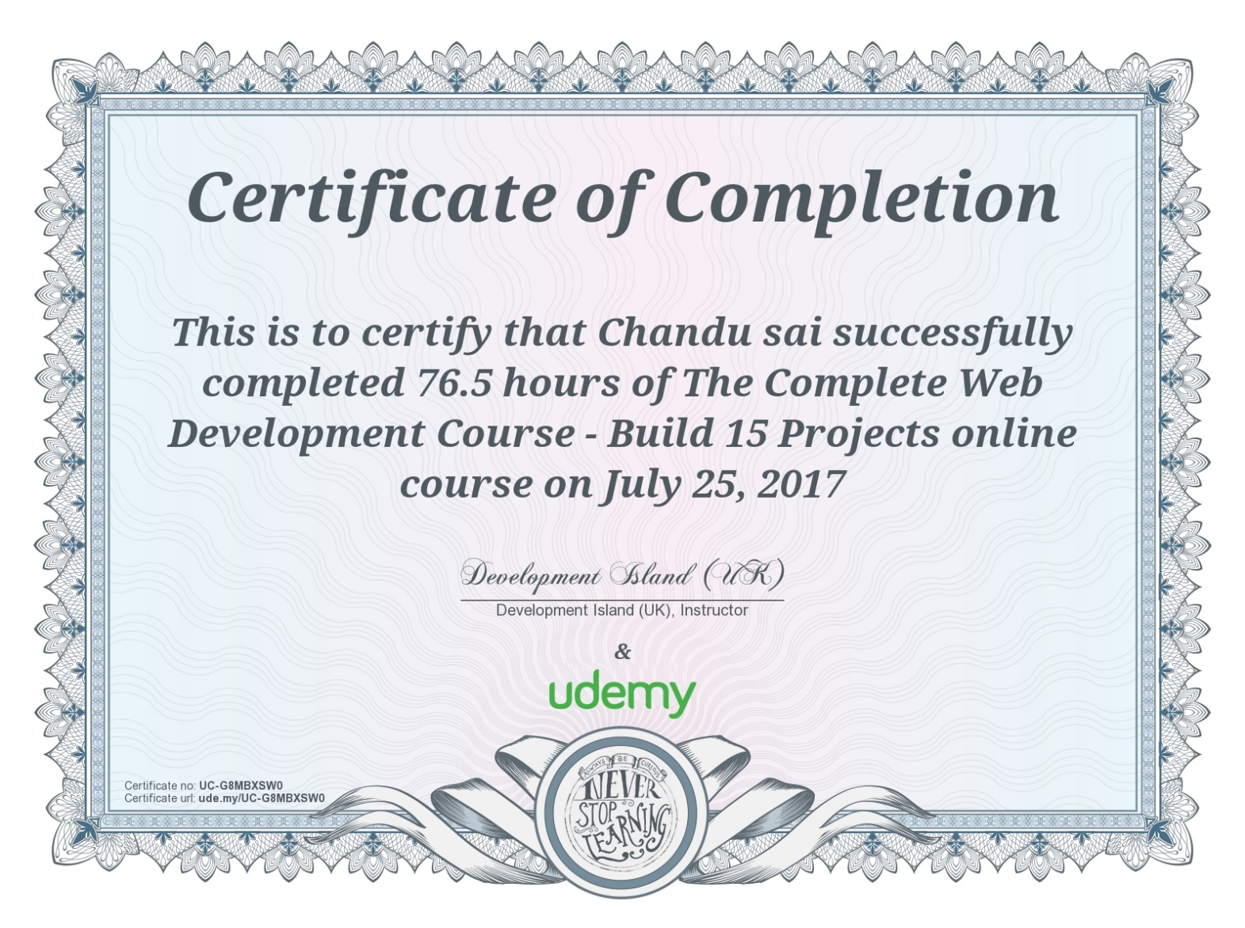

**Table of Contents**

|  |  |  |
| --- | --- | --- |
| S. No. | Topics | Page No. |
| 1. | Introduction | 6 – 7 |
| 2. | Technology learnt | 7-8 |
| 2.1. | Software used | 8-10 |
| 2.2. | Scope of Web Development in IT Industry | 11-12 |
| 3. | Reason for choosing this technology | 13 |
| 4. | Learning outcomes from this Technology | 14-15 |
| 5. | Gantt chart | 16 |
| 6. | Bibliography | 17 |

1.**Introduction**

**Overview of the Organization**

**Udemy.com** is an online learning platform. It is aimed at professional adults. Unlike academic MOOC programs driven by traditional collegiate coursework, Udemy provides a platform for experts of any kind to create courses which can be offered to the public, either at no charge or for a tuition fee. Udemy provides tools which enable users to create a course, promote it and earn money from student tuition charges.

**Overview of the Course**

If you are serious about becoming a web developer, then you already know that you need the most current and complete new technologies training possible. To succeed in this competitive industry, it is essential to have an expert knowledge of the entire web development pipeline. Whether it’s your goal to work for a big companies, or to develop and publish your own e-commerce websites, one thing is clear, you will need to be well trained as both a programmer and an artist.

**Web-Development**

I have done my training in web development, So let’s get started with first defining what web development is and what role does it play in today’s world and we will discuss various kinds of technologies and tools that is needed for developing various websites. So here we go….

1. What is Web Development and what is its importance??

* Web programming, also known as web development, is the creation of dynamic web applications. Examples of web applications are social networking sites like Facebook or e-commerce sites like Amazon.
* The good news is that learning web development is not that hard!
* In fact, many argue it’s the best form of coding for beginners to learn. It’s easy to set up, you get instant results and there’s plenty of online training available.

A lot of people learn web coding because they want to create the next Facebook or find a job in the industry. But it’s a good choice if you want a general introduction to coding, since it’s super easy to get started. No matter whether you are looking for a career or just want to learn coding, learning how to develop for the web is for you. It’s one of the smartest decisions you will ever make.

There are two broad divisions of web development

* Front-end development (also called client-side development)
* Back-end development (also called server-side development)

* Front-end development refers to constructing what a user sees when they load a web application – the content, design and how you interact with it. This is done with five codes
* HTML
* CSS
* JavaScript
* JQuery
* Bootstrap
* Back-end development controls what goes on behind the scenes of a web application. A back-end often uses a database to generate the front-end

Back-end scripts are written in many different coding languages and frameworks, such as…

* PHP
* Ruby on Rails
* ASP.NET
* Perl
* Java
* Node.js
* Python

**2. Technology Learnt**

**Name of the Course: The Complete Web Development**

**About the Course**

Throughout the Six Week Training program, I had learnt beginner level techniques in the Web Development.

I learnt techniques and workflows of Different ways to make Web applications who have been working in the developing industry for over 10 years and have a passion for making great Websites and Web Applications.

I was extensively trained on programs like HTML, CSS WORDPRESS, JAVASCRIPT, JQUERY, BOOTSTRAP, PHP, and MYSQL. Learning powerful tools like these are made easy with fun projects that are designed to take the fear out of learning such advanced software.

* My training started with HTML, which is a basic Coding that has been used by countless Web developers all over the world to build some amazing Web applications. HTML’s intuitive and user-friendly interface is an excellent place to start your path to becoming a Web Developer. I started by learning the fundamentals of Web Development , giving a great foundation for me to get excited and confident to move on to more Web projects which will have building incredible worlds. In addition to learning how to code in the JAVASCRIPT programming language, letting you create any dynamic elements your imagination can come up with.
* After you have learned HTML and JAVASCRIPT it is time to move on and learn how to create your small Website.
* I learnt to use CMSs like WORDPRESS.WordPress is a free and open-source content management system (CMS) based on PHP and MySQL. WordPress is reportedly the most popular website management or blogging system in use on the Web, supporting more than 60 million websites

* It was an exciting journey throughout these Six weeks and I learnt from the best mentor in this field which showed me proper guidance throughout this course and made it easy for a beginner like me to understand and complete this training.

**2.1. Software Used:**

**HTML:**

**Hypertext Markup Language** (HTML) is the standard markup language for creating web pages and web applications. With Cascading Style Sheets (CSS) and JavaScript it forms a triad of cornerstone technologies for the World Wide Web. Web browsers receive HTML documents from a webserver or from local storage and render them into multimedia web pages. HTML describes the structure of a web page semantically and originally included cues for the appearance of the document.

**Cascading Style Sheets (CSS):**

Cascading Style Sheets (CSS) is a style sheet language used for describing the presentation of a document written in a markup language. Although most often used to set the visual style of web pages and user interfaces written in HTML and XHTML, the language can be applied to any XML document, including plain XML, and is applicable to rendering in speech, or on other media. Along with HTML and JavaScript, CSS is a cornerstone technology used by most websites to create visually engaging webpages, user interfaces for web applications, and user interfaces for many mobile applications.

**JAVASCRIPT:**

JavaScript is a dynamic computer programming language. It is lightweight and most commonly used as a part of web pages, whose implementations allow client-side script to interact with the user and make dynamic pages. It is an interpreted programming language with object-oriented capabilities. JavaScript was first known as Live Script.

**jQuery:**

jQuery is a cross-platform JavaScript library designed to simplify the client-side scripting of HTML. It is a free, open-source software using the permissive MIT license. Web analysis indicates that it is the most widely deployed JavaScript library by a large margin. jQuery’s syntax is designed to make it easier to navigate a document , select DOM elements, create animations, handle events, and develop Ajax applications.

JQuery also provides capabilities for developers to create plug-ins on top of the JavaScript Library. This enables developers to create abstractions for low-level interaction and animation, Advanced effects and high-level, themeable widgets. The modular approach to the jQuery Libarary allows the creation of powerful dynamic web pages and web applications.

**Bootstrap:**

Bootstrap is a free and open-source front-end web framework for designing websites and web applications. It contains HTML- and CSS-based design templates for typography, forms, buttons, navigation and other interface components, as well as optional JavaScript extensions. Unlike many web frameworks, it concerns itself with frontend development only.

Bootstrap 3 supports the latest versions of the Google Chrome, Firefox, Internet Explorer, Opera, and Safari (except on Windows). It additionally supports back to IE8 and the latest Firefox Extended Support Release (ESR).

Bootstrap is modular and consists of a series of Less stylesheets that implement the various components of the toolkit. These stylesheets are generally compiled into a bundle and included in web pages, but individual components can be included or removed. Bootstrap provides a number of configuration variables that control things such as color and padding of various components.

**PHP:**

PHP is a server-side scripting language designed primarily for web development but also used as a general-purpose programming language. it now stands for the recursive acronym PHP: Hypertext Preprocessor. PHP code may be embedded into HTML or HTML5 markup, or it can be used in combination with various web template systems, web content management systems and web frameworks. PHP code is usually processed by a PHP interpreter implemented as a module in the web server or as a Common Gateway Interface (CGI) executable. The web server software combines the results of the interpreted and executed PHP code, which may be any type of data, including images, with the generated web page. PHP code may also be executed with a command-line interface (CLI) and can be used to implement standalone graphical applications.

**MYSQL:**

MySQL is an open-source relational database management system (RDBMS). Its name is a combination of "My", the name of co-founder Michael Wideners' daughter, and "SQL", the abbreviation for Structured Query Language. The MySQL development project has made its source code available under the terms of the GNU General Public License, as well as under a variety of proprietary agreements. MySQL was owned and sponsored by a single for-profit firm, the Swedish company MySQL AB, now owned by Oracle Corporation. For proprietary use, several paid editions are available, and offer additional functionality.

MySQL is a central component of the LAMP open source web application software stack (and other "AMP" stacks). LAMP is an acronym for "Linux, Apache, MySQL, Perl/PHP/Python".

Applications that use the MySQL database include: TYPO3, MODx, Joomla, WordPress, phpBB, MyBB, and Drupal. MySQL is also used in many high-profile, large-scale websites, including Google (though not for searches), Facebook, Twitter and YouTube.

**WordPress:**

WordPress is an open source Content Management System (CMS), which allows the users to build dynamic websites and blog. WordPress is the most popular blogging system on the web and allows updating, customizing and managing the website from its back-end CMS and components.

The Content Management System (CMS) is a software which stores all the data such as text, photos, music, documents, etc. and is made available on your website. It helps in editing, publishing and modifying the content of the website.

WordPress is installed on a web server that is either part of an Internet hosting service or a network host in its own right. The first case may be a service like WordPress.com, for example, and the second case could be a computer running the software package WordPress.org.

**2.2. Scope of Web Development in IT Industry:**

The swelling wave of e-Commerce dominance fuelling the need for organizations to establish their online presence has led to the emergence of Web Designing as an important organizational function. More and more organizations are recruiting internal Web Designing teams or are employing external agencies to dish out professional and functional websites for them.

In this scenario therefore, Web Designing in India as a career option has gained immense prominence. An increasing number of young enthusiasts are heading towards design institutes to be accredited with the mark of being an expert in Web design. However, there is a need to understand the discipline prior to jumping into the fray unprepared.

Understanding the Basics of Web Designing

The basic role of a web designer entails one to employ several skills sets in the production and maintenance of Web Sites. To deliver appropriate quality, they would need to harness knowledge in the following areas:

• Graphic design

• Interface design

• Authoring using standardized code and proprietary software

• User experience design

• Search engine optimization

While the above mentioned are merely enablers that help him or her bag the job the real skill set required to enable them to keep the job goes much deeper than this. It centres on the inherent need for a Web Designer to possess an aesthetic sense and an ability to empathize with the audience to deliver an enhanced web viewing experience through their designs.

**Tools and Technologies**

Technology is ever evolving. As a result, Web designs based on these technologies would also need to be redefined with every evolutionary phase. Nevertheless, there are several standard tools which would always be in demand by Web Designers. These include:

• HTML and CSS and Many Programming languages.

• Programming skills

**Career Opportunities**

Web Designing is a promising career opportunity which displays immense scope for interested candidates. In India, one of the biggest industry, which provides a prospective scope for Web Designing as a career opportunity is the IT or the software industry. Clients interested in getting their online presence established are approaching the software giants to get their Web sites designed. Therefore, the software stalwarts recruit experienced professionals who would be sufficiently qualified in executing the deliverables in quick turnaround time.

In addition, they also welcome Freshers who are put through rigorous training and then made to learn the ropes under the wings of the experienced seniors. This provides them with an excellent opportunity to learn the work hands-on.

Most organizations also recruit web designers for their internal projects which have a distinct flavor of their own as it provides the opportunity for Designers to interact with major company stakeholders who run these internal initiatives.

Web Designers are also required in the Media Industry like News or advertising agencies or even in the education industry developing educational websites and learning material for students.

**3. Reason for choosing this technology**

1. **It Pays Well**

Web developers can expect a higher than average wage than people in other industries with the same amount of experience. Many employers are happy to employ those who didn’t go to university as well, due to skilled, self-taught programmers being so common, and so it actually offers a well above average wage for non-graduates too.

1. **It’s Creative and technical**

Ask any web developer what their average day is like. They’ll tell you every day is different. Whereas many technical jobs feature the same day in day out, front-end web developers work on new creative projects all the time. It’s the combination of analytical, logical thought with the ability to make new things and find new ways to do things that no-one has done before, that makes the work so exciting for developers – no matter how many years they’ve been at it.

1. **Work wherever you want**

Trained web developers benefits from a great amount of freedom in when, where and how they work. Web experts are needed in all industries, including online recruitment, and may work in-house (for one company) or on the agency side (for many companies and brands). Or by going freelance, you can set your own rate and work on whatever schedule you want, wherever you want!

1. **Web development can be exciting**

As compare to other IT jobs web designing is more exciting. In other IT job natures you keep doing same thing which makes you bored. Where as in Web designing you constantly keep working on new projects. Face new challenges and apply your skills to solve it and apply your creativity in your work. Being a web designer you apply new art and ideas constantly which increase interest in works.

1. **We can learn by our own**

Every technical course require technical skill and long training and guideline to get expertise in their working domain but here you keep learning everyday by your own. You think and analyze things with more creativity which adds more and more value to your career.

**4. Learning outcomes**

• Build professional websites

• Build HTML-based mobile apps

• Get a job as a junior web developer

• Bid for projects on freelance websites

• Start their own online business

• Be a comfortable front-end developer

• Be proficient with databases and server-side languages

**Learning Main Topics**

* HTML
* CSS
* JavaScript
* jQuery
* Bootstrap
* WordPress
* PHP
* MySQL

.

**The Future Web Development :**

**1. USING AI TO CREATE WEBSITES**

Artificial intelligence programs are already used successfully by Google and Wikipedia, the technology is more than within our grasp to allow us to develop software which can think and act as a human without requiring the manpower.

One of their most prolific uses already is for web design programs, such as The Grid, which allows amateurs to produce some slick websites by using an artificial intelligence program named Molly.

You create the content, Molly does the rest.

**2. STATIC SITE GENERATORS**

The reason we believe that the popularity of static site generators keeps going up is simple.

Static site generators are a great way to create websites. You don’t need a database, instead your web pages are simple files which run on your servers. With that comes advantages in website loading times, better security handling, and ease of deployment.

**3. MOTION UI**

In past last year’s article on the best web development trends for 2016 we predicted an increased popularity of motion user interfaces.

And you, our readers, agreed with that. With 36% (or 2382 votes) you stated that this will be the most important development trend for you in 2016. The newest version of Motion UI works through flexible CSS patterns with all kinds of JavaScript libraries and enables seamless integration of animations into websites.

**4. THE EVOLUTION OF JAVASCRIPT IN 2017**

So, let’s start with JavaScript right away. I know there’s even more buzz around JavaScript and its relevancy. However, it is by far the most popular technology used by full stack developers.

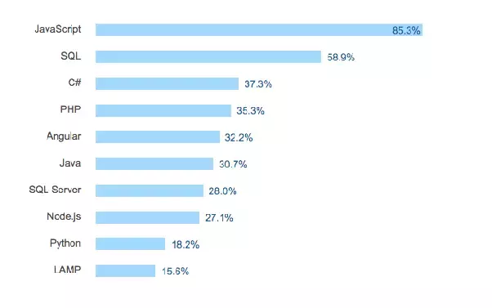

**5. GANTT CHART**

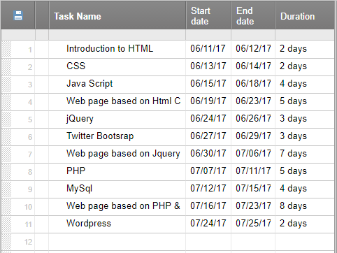

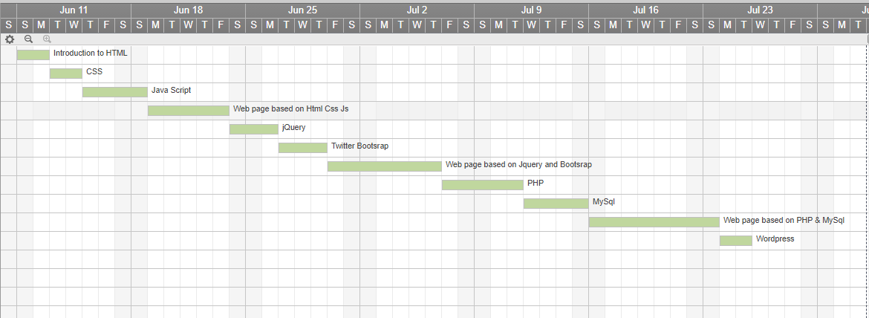

1. **BIBLIOGRAPHY**

* https://www.udemy.com
* https://www.udemy.com/complete-web-development-course/learn/v4/overview
* https://www.wikipedia.com
* https://www.w3schools.com/